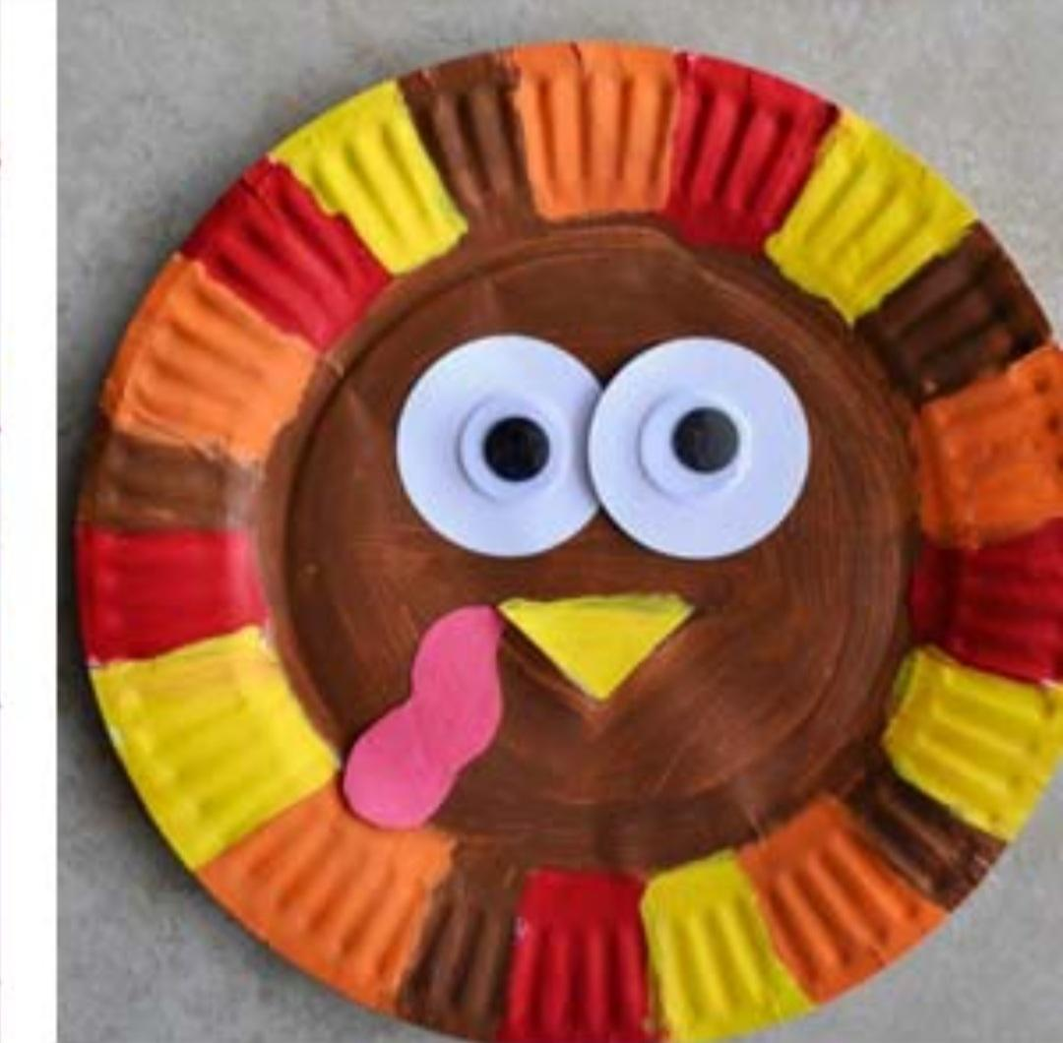

Turkey Craft Supplies
1 large white paper plate
1 sheet of white paper
2 large wiggle eyes
1 yellow sheet of construction paper
1 red sheet of construction paper
Yellow, orange, red and brown markers
Craft glue
Safety scissors

