South Huntington Library with Chef Kathryn
Berry-Almond Chia Amaranth Porridge
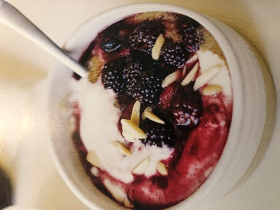
3/29/2021
Serves 2
Ingredients:

½ cup amaranth
2 cups water
2 teaspoons chia seeds
2 cups frozen mixed berries (such as strawberries, blueberries, and blackberries)
2 tablespoons maple syrup( grade B, if possible)
1/4 teaspoon ground cinnamon
½ cup vanilla nondairy yogurt, unsweetened
½ teaspoon almond extract (optional)
2 tablespoons silvered almonds (optional)
Garnish: for a brain boost, top each bowl with a tablespoon of goji berries

Procedure:

- In a small pot, mix together the amaranth and water and place the pot over high heat. Bring to a boil, and then reduce the heat to low. Let the mixture simmer gently for 15-20 minutes, uncovered, or until the amaranth is chewy and tender and a thick porridge has formed. Stir the mixture frequently during the last few minutes of cooking to avoid burning.
- Meanwhile, place the berries in a separate small pan over low heat for a few minutes, until the fruit is completely defrosted and it is juicy. Remove the pan from the heat and stir in the maple syrup and spice. Cover the pan to keep the berry mixture warm. In a bowl whisk together the yogurt and almond extract, if using.
- Divide the amaranth porridge into the bowls and swirl in the yogurt mixture, along with the berries and their juices. Top with almonds and serve.
Chef’s Notes:
To make this recipe sugar free, use two tablespoons monk fruit sweetener as a substitute

Recipe by Chef Kathryn Bari-Petritis, 2021, Adapted from, Smart Plants, Julie Morris
Kathryn@thehealthchef.com, www.thehealthchef, Social: Instagram, Kathrynp51

